MAIN PROJECT ROUGH RECORD
TOPIC:AI COUNSELLOR

Submitted By
ASWINI K.S
Roll no :23

ABSTRACT

This is a machine learning-based speech emotion recognition project. The AI counsellor is a speech emotion recognition system.It take speech as input. It attempting to recognize human emotion and effective states from speech.This is capitalizing on the fact that voice often reflects underlying emotion through tone and pitch. The emotionbased
AI counselor is a module of the Track My School project,The school has implemented a councilor in the school to cater to their needs. They have only some time for counseling sessions. It is not effective due to lack of time. So we introduced AI Student Counselor, who relies on the student’s emotion through voice input. This may be for counseling sessions via automated phone calls / chat-bots.AI counsellor filtered and assigned counsellors based on emotions. This project consist of 3 Modules.First registration module .Second gender recognition
module and third is emotion sensing module.

EXISTING SYSTEM
In the existing system, the school have a counselling session in every weekends to cater the needs of the students.psychological behavior of students is just as important as that of educators. For this purpose, the school has implemented a councilor . For school educators academics is very important because they have only some time for
counseling sessions so it is not effective due to lack of time. Also it was for a whole class so the student with psychological issues would not come forward due to the fear inside them.
Proposed System

In the proposed system , an AI counsellor is introduced and would sense the emotion of the student filtered with gender classification. The proposed system is one to one communication system and it would assign the counsellor based on the emotion they have .It would be easier for the end counsellor to evaluate their problem and suggest proper solution . Since the system is automated on AI basis , the time
consuming is very less and that would add up the relevancy of the project. Since the
counselling is filtered and assigned counsellors are based on the emotions the system is very effective as compared to the existing system.
• The proposed system counseling sessions via automated phone calls / chat-bots
• AI counsellor take voice as input recognize gender of student and would sense
the emotion of the student.
• The system will sense emotions like sad, happy, angry, calm, fearful, disgusting,
shocking, neutral.
• Assign student to the counsellor based on emotion they have.

MODULE DISCRIPTION
Registration Module
In registration module admin can register staffs and students using their details like name,email-id,address,date of birth,mobile etc...

Gender Recognition Module

In Gender Recognition we use a data set of 3000 observation of both male and female. We check them variables as like mean,median and mode frequency,first ,third and inter quantile special entropy and modulation etc..We then compare the target and independent variable using histograms. Using decision tree , gradient boosting the gender is specified.
Emotion Sensing Module

In emotion sensing , we use data set of sound modulation in sad, happy, angry etc moods. A function is defined to extract the features. We then extract the feeling using glob function to define the each emotions. We then train the models and initialize MLPClassifier for classification. We evaluate the individual voice to the train model to classify the emotion.

DATA FLOW DIGRAM

CONTEXT LEVEL

LEVEL 1

LEVEL 2

FLOW DIGRAM

STUDENT TABLE

Filed name | Data type | constrins | description
First name | Varchar | Notnull
Last name | varchar | Notnull
Full name | Varchar | Notnull
Email | Varchar | Notnull
Mobile | Int | Notnull
Date of birth | Date | Notnull
Registration date | Date | Notnull
Admission nmber | Int | Notnull
Photo | Varchar | Notnull
Permenant address | Varchar | Notnull
Additional notes | Varchar | Notnull
Document titile | varchar | Notnull
Active status | Tinyint | Notnull
Created at | Tinyint | Notnull
Updated at | Tinyint | notnull
Blood group | Varchar | Notnull
Role id | Int | Notnull
Gender id | Int | Notnull
Height | Int | Notnull
Weight | Int | Notnull
Seesion | Int | Notnull
Father name | Varchar | Otnull
Mother name | Varchar | Notnull
occupation | varchar | Notnull

STAFF TABLE
FILED NAME | DATA TYPE | CONSTRAINTS | DESCRIPTION
Id | int | Primary key
First name | varchar | Not null
Last name | Varchar | Notnull
Full name | Varchar | Notnull
Father name | Varchar | Notnull
Mother name | Varchar | Notnull
Staff no | Int | Notnull
Date of birth | Date | Notnull
Date of joinig | Date | Notnull
Email | Varchar | Notnull
Mobile no | Int | Notnull
Emergency no | Int | Notnull
Marital status | Varchar | Notnull
Photo | Varchar | Notnull
Current address | Varchar | Notnull
Permenat address | Varchar | Notnull
Qualification | Varchar | Notnull
Experience | Varchar | Notnull
Epf no | Int | Notnull
Basic salary | Int | Notnull
Contract type | Varchar | Notnull
Location | Varchar | Notnull
Casual leave | Varchar | Notnull
Medical leave | Varchar | Notnull
Twitter url | Varchar | Notnull
Linkedin url | Varchar | Notnull
Joining lerter | Varchar | Notnull
Resume | Varchar | Notnull
Other document | Varchar | Notnull
Depart ment id | Int | Notnull
designation | Varachr | Notnull

LOGIN TABLE

FILED NAME | DATA TYPE | CONSTRAINTS | DESCRIPTION
Id | Int | notnull
Full name | Varchar | notnull
Use name | Varchar | Notnull
Password | Varchar | Notnull
Email | Varchar | Notnulll
Use type | Varchar | Notnull
Access status | tinyint | Notnull
Active status | tinyint | Notnull
Notification token | text | Notnull
Remember token | Int | Notnull
Created by | Int | Notnull
Updated by | Int | Notnulll
School id | Int | Notnull
Role id | Int | Notnull
Active status | tinyint | Notnulll

PRODUCT BACKLOG`

SERIAL NO | DECRIPTION | PRIORITY
1 | Database creation of male and female | 1
2 | Train models of male and female | 2
3 | Database creation of test model with emotions | 3
4 | Train emotions of test models | 4
5 | classify test models based on emotions | 5
6 | Recognize emotions of individuals | 6
7 | Database creation of counsellor with emotion priority | 7
8 | Assign student to counsellor | 8

SPRINT BACKLOG

SL NO | DATE | SPRINT GOAL | STATUS
1 | 31/3/21 To  5/4/21 | Discussion of topics and requirments | completed
2 | 10/4/21 To  15/4/21 | Table design | completed
3 | 19/4/21  To  30/4/21  15/4/21 | Dfd ,Form design  coding | Completed  completed

SOFTWARE AND HARDWARE SPECIFICATION

HARDWARE SPECIFICATION
· 32 bit or 64 bit
· 2 GB RAM
· Intel i3

SOFTWARE SPECIFICATION
· OS: windows 7 or above
· Framework: Django
· Browser: Any browser
· Front_end: Python
· Backend:MySql

FORM DESIGN
Student Registration

Staff Registration

Login

Admin Home

Chat-bot Screen

Voice Recognition

Emotion Detection

Code

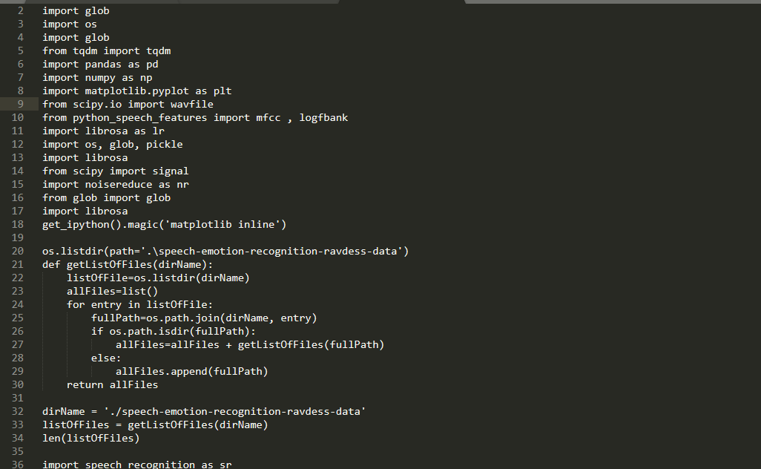

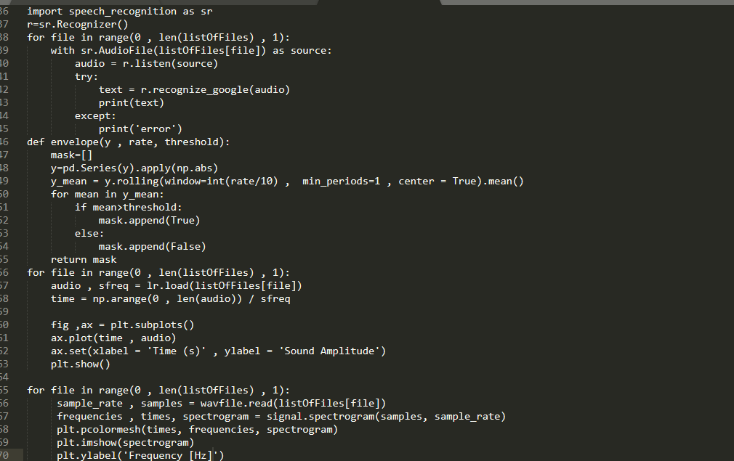

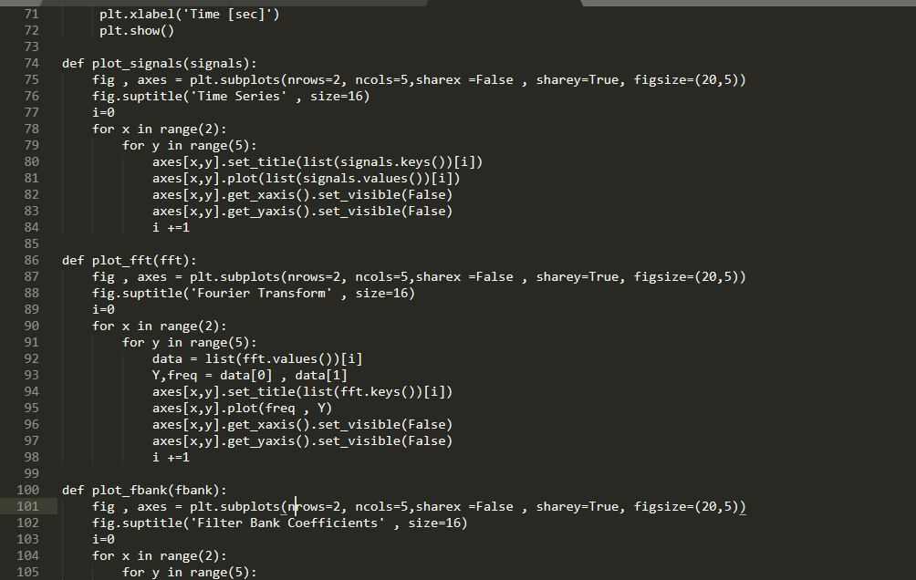

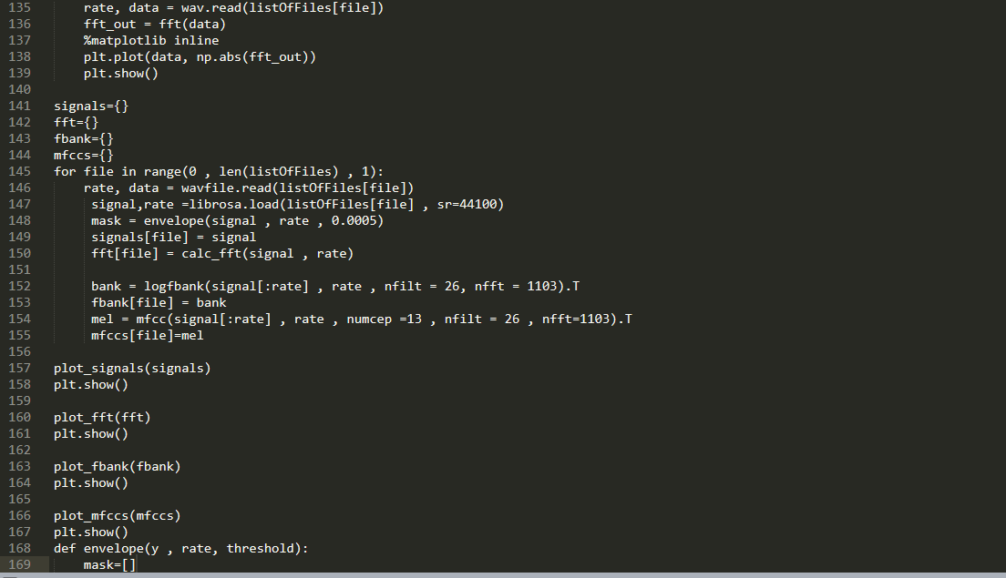

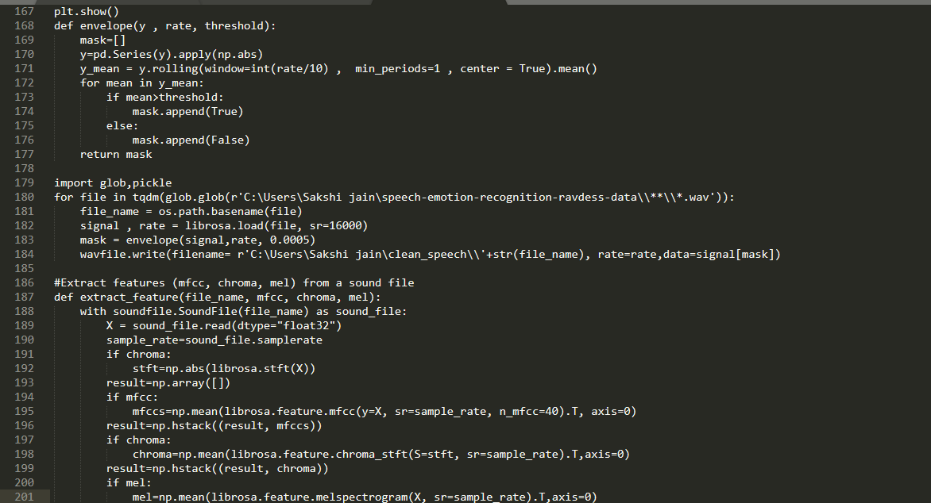

CONCLUSION
AI COUNSELLOR is a speech emotion recognition system. The system will
understand the feeling of student through voice input. It is a chatbot where a user can register and give voice as input.The AI based counselor who understands the feelings of the students . The emotions we use are sad, happy, angry, calm, fearful, disgusting,shocking, neutral.The psychological behavior of students is just as important as that of educators. For this purpose, the school has implemented AI counsellor it would sense the emotion of the student filtered with gender classification. The is one to one communication system and it would assign the counsellor based on the emotion they have .It would be easier for the end counsellor to evaluate their problem and suggest proper solution . Since the system is automated on AI basis , the time consuming is very less and that would add up the relevancy of the project.

